COVID-19 Exposure Prevention Plan

C. Gessner and S. Shimko

Policy-13 (release 4.1)

Release Date: 2020-05-20

Revision Date: 2021-02-10

This document is under change control. Its contents may not be changed, altered or their provisions waived without approval via the NOIRLab change control process. If this document is changed, the new release will retain the Handle designation shown above. Control is exercised via the preferred version in NOIRLab’s DocuShare digital archive and not printed versions.
Table of Contents
1. What is COVID-19? 7
1.1 How is COVID-19 Spread? 7
1.2 Basic Steps to Lower Your Risk 7
1.3 Symptoms of COVID-19 8
1.4 When to Seek Medical Attention 9
1.5 Vulnerable Individuals 9
2. Management Responsibilities 9
2.1 Training 9
2.2 COVID-19 Site Access Questionnaire Instructions 9
2.3 Active Screening 10
2.3.1 Active Screening Process 11
2.4 Alternative Active Screening 11
2.5 Site Inspections 11
2.6 Contact Tracing 11
2.7 COVID-19 Testing in Screening 11
3. Guidance for Conditions of COVID-19 Exposure 12
3.1 Employee Exhibits COVID-19 Symptoms 12
3.2 Employee Confirmed Positive for COVID-19 12
3.2.1 Cleaning Protocol 13
3.3 Employee Has Close Contact with an Individual who has tested Positive for COVID-19 13
4. Exposure Reduction Requirements 15
4.1 Personal Hygiene 15
4.2 Social Distancing 15
4.3 Personal Protective Equipment 16
4.3.1 Mask Wearing 16
4.3.2 Use of N95 Respirators 17
4.3.3 Gloves 17
4.3.4 Other PPE 17
4.3.5 Disposal of PPE and Cleaning Materials 17
5. Building Access 17
5.1 Minimizing Exposure at Facilities 17
5.2 Building Cleaning Practices 18
5.3 Cleaning Equipment and Tools 18
5.4 Food Handling 18
6. Vehicle Use 19
6.1 Social Distancing in Vehicles 19
6.2 Cleaning Company Vehicle 20
6.3 Clean and Disinfecting Vehicles 20
7. Stop Work Authority and Reporting Non-Compliance 20
8. Summit/High-Altitude Safety Considerations 21
8.1 Altitude Issues 21
8.2 Face Mask Use at Altitude 21
8.3 Illness and Injuries 21
8.4 Transportation for Illness or Injury 22
8.5 Oxygen Self-Administration 22
8.6 CPR 22
9. Clean Site Checklist 22
10. Disinfecting Instructions 24
11. Appendix A: Sample COVID-19 Site Access Questionnaire 25
12. Appendix B: Sample Site Inspection Checklist 27

  - Change Record
Release | Date | Description | Change Owner
1.0 | 2020-05-20 | Initial release. | Daniel Calabrese
2.0 | 2020-08-31 | Removed reference to Phases, added new exposure reduction requirements and Guidance for Conditions of Exposure | C. Gessner, S. Shimko, V. Schnader
3.0 | 2020-11-10 | Updated symptoms 1.3 and added new site access questionnaires, testing guidance added | C. Gessner, S. Shimko, V. Schnader
4.0 | 2021-01-12 | Corrected virus definition in section 1, added close contact guidance in section 3.3, modified vehicle use in section 6.1 | C. Gessner, S. Shimko, V. Schnader
4.1 | 2021-02-10 | Added mask wearing clarifications in Section 4.3.1 | C. Gessner, S. Shimko, V. Schnader

  - Purpose
AURA and its NSF National Optical Infrared Astronomy Research Laboratory (NOIRLab)are committed to the health and safety of our staff at all locations. In late March 2020, due to the COVID-19 worldwide pandemic, facilities were closed, and staff began working under an emergency telework procedure. This document defines the Safety and Health requirements and procedures for the process of phasing-in the return of some of our staff that will begin to enable the observatories. This document applies to all contractors, collaborators, and visitors that may be allowed on site.
This plan mandates requirements and procedures intended to minimize COVID -19 exposure and spread at the workplace. Failure to comply with the requirements and procedures of this document shall be considered a breach of contract, agreement, or a serious infraction and, depending on the violation, may result in termination of the contract, agreement, employment, disciplinary action, or other sanctions at the discretion of management. In Chile, the disciplinary actions, including work termination, will be made in compliance with the existing labor regulations.
Nothing contained in this plan shall be interpreted to guarantee or assure the health, safety or wellbeing of anyone entering the site, or that the site will be free of COVID-19. In no event shall this document give rise to an independent cause of action or provide any additional personal or governmental rights or liabilities.
This plan is based on information available from the CDC, OSHA, local jurisdictions, and the Chilean government at the time of its development and is subject to change based on further information provided by the CDC, OSHA, Chilean Labor Law and protocols of the Chilean Ministry of Health (MINSAL), and other public officials. This plan may be amended based on changing operational needs. To help ensure the health and safety of our staff, AURA reserves the right, at any time, to implement more stringent requirements than those mandated or recommended by the CDC, OSHA, and local jurisdictions and the Chilean government.

  - References
- CDC Interim Guidance for Businesses and Employers to Plan and Respond to Coronavirus Disease 2019 (COVID-19)
- OSHA 4000, OSHA Alert COVID-19 Guidance for the Construction Workforce, 04 2020
- OSHA 3990, Guidance on Preparing Workplaces for COVID-19, 03 2020
- CDC Interim Guidance for Emergency Medical Services (EMS) Systems and 911 Public Safety Answering Points (PSAPs) for COVID-19 in the United States, March 10, 2020
- ASSP Hawaii Chapter, COVID-19 Best Practices for a Construction Site, April 2020 Chapter Meeting Webinar
- The Laborers’ Health & Safety Fund of North America Recommended COVID-19 Response Plan for Construction Employers, 3/20/20
- General Contractors Association of Hawaii Sample COVID-19, Jobsite Policy, April 10, 2020
- Chilean Labor Code
- Chilean Ministry of Health
- Chilean Work Accident Law 16.7444

COVID-19 Exposure Prevention Plan

What is COVID-19?
The novel coronavirus, SARS-CoV-2 is one of seven types of known human coronaviruses. SARS-CoV-2, like the MERS and SARS coronaviruses, likely evolved from a virus previously found in animals. The remaining known coronaviruses cause a significant percentage of colds in adults and children, and these are not a serious threat for otherwise healthy adults. COVID-19 is the disease that the SARS-CoV-2 causes.
Patients with confirmed COVID-19 infection have reportedly had mild to severe respiratory illness with symptoms such as fever, cough, and shortness of breath.
According to the U.S. Department of Health and Human Services/Centers for Disease Control and Prevention (“CDC”), Chinese authorities identified an outbreak caused by a novel—or new—coronavirus. The virus can cause mild to severe respiratory illness, amongst other impacts. The outbreak began in Wuhan, Hubei Province, China, and has spread to a growing number of other countries—including the United States.

How is COVID-19 Spread?
COVID-19, like other viruses, can spread between people. Infected people can spread COVID-19 through their respiratory secretions, especially when they cough or sneeze. According to the CDC, spread from person-to-person is most likely among close contacts (about 6- feet or 2 meters). Person-to-person spread is thought to occur mainly via respiratory droplets, produced when an infected person talks, coughs or sneezes. These droplets land in the mouths or noses of people who are nearby or possibly be inhaled into the lungs. It may be possible that a person can get COVID-19 by touching a surface or object that has the virus on it and then touching their own mouth, nose, or possibly their eyes, but this is not thought to be the main way the virus spreads.

Basic Steps to Lower Your Risk
Stay home if you are sick or have had close contact with someone who is sick. These are not normal times, and a return to AURA facilities should not be considered a return to “normal” as existed prior to the pandemic. If you are granted access to the workplace, you must follow the recommendations given by AURA. These include, but are not limited to:
- While on site, everyone must wear AURA-provided masks fully and snugly over the nose and mouth. See Section 6.1 for more details.
- AURA provided masks must be worn while in public spaces in buildings until further notice. Public spaces include labs, work areas, instrument shops, restrooms, corridors, and other open areas where social distancing may not be possible and other people may be present.
- An AURA provided mask must be worn or kept with you while on site, at all times.
- Wearing a mask outside is generally not required unless it is mandated to do so by a local jurisdiction, including but not limited to federal, state, county, city, property owners, and universities. However, masks must be worn outside in immediate environment circumstances, such as standing in a congested area, where six feet (2 meters) of separation between individuals is not possible.
Employees should:
- Safely maintain at least six feet of separation between other individuals onsite.
- Avoid physical contact, including handshakes and hugging.
- Avoid areas of congestion. Wear your mask if you find yourself in an area of congestion.
- Use the disinfectant spray or wipes to clean your work surfaces before starting work and after completion of the work.
- Wash your hands at the start of the shift and frequently thereafter for at least 20 seconds, or use hand sanitizer with 60% to 95% alcohol if hand washing is not available.
- Always cover your mouth and nose with a tissue, the crook of your arm, or your sleeve (not your hands) when coughing or sneezing.
- Avoid touching your eyes, nose, or mouth.
- Touch as little as possible and wipe down surfaces after touching them when possible.
- Minimize your time onsite if possible.
- Wearing your mask in a private area such as a single occupancy office is not required. However, even if a space is otherwise private, masks should be worn by all parties if others visit this space (e.g. a person in an office should wear a mask if they have a visitor, as should the visitor).

Symptoms of COVID-19
People with COVID-19 have had a wide range of symptoms reported – ranging from mild symptoms to severe illness.
Symptoms may appear 2-14 days after exposure to the virus. People with these symptoms may have COVID-19:
- Cough (persistent or dry cough)
- Shortness of breath or difficulty breathing
- Fever (100.4 degrees F or higher) or chills
- Fatigue
- Sore throat
- Muscle or body aches
- Headache
- New loss of taste or sense of smell
- Congestion or runny nose
- Nausea or vomiting
- Diarrhea
This list does not include all possible symptoms.

When to Seek Medical Attention
Look for emergency warning signs* for COVID-19. If someone is showing any of these signs, seek emergency medical care immediately:
- Trouble breathing
- Persistent pain or pressure in the chest
- New confusion
- Inability to wake or stay awake
- Bluish lips or face
*This list is not all possible symptoms. Please call your medical provider for any other symptoms that are severe or concerning to you.
Call 911 or call ahead to your local emergency facility: Notify the operator that you are seeking care for someone who has or may have COVID-19.

Vulnerable Individuals
If you believe you have a pre-existing condition that puts you at higher risk of severe illness and have been called back to work at an AURA facility, contact your Human Resources professional to discuss concerns or to request possible special accommodations. CDC defines high risk as age 65 or older, chronic lung disease, moderate to severe asthma, serious heart conditions, immunocompromised (including cancer treatment, smoking, bone marrow or organ transplantation, immune deficiencies, poorly controlled HIV or AIDS, or prolonged use of corticosteroids and other immune weakening medications), severe obesity (body mass index of 40 or higher), diabetes, chronic kidney disease undergoing dialysis, or liver disease.

Management Responsibilities
All managers and supervisors shall be familiar with this plan and shall follow and enforce the requirements and procedures of this plan.

Training
Management is required to ensure all workers scheduled to return to work received the Human Resources and exposure prevention training, before reporting to work at AURA facilities.

COVID-19 Site Access Questionnaire Instructions
After being requested to return to an AURA facilities site, workers will be presented the Site Access Questionnaire during mandatory exposure prevention training.
Contractors, collaborators and visitors who answer “Yes” must notify the Site/Safety Manager and the Center Director must be notified. The Center Director shall coordinate necessary actions with the AURA Chief of Staff.
Workers are to be told, if they are answering “Yes” to any of the questions:
In the United States:
- Not to enter AURA facilities/sites.
- Immediately contact Human Resources.
- Follow Human Resources guidance in obtaining COVID-19 RT-PCR* testing.
*FDA: molecular tests (also known as diagnostic test, viral test, molecular test, nucleic acid amplification test? (NAAT, RT-PCR test, LAMP test)
- Remain at home until COVID-19 results are available, then provide the test results to Human Resources.
If the employee tests negative for COVID-19, they may return to work after the test documentation is provided to Human Resources, and Human Resources approves the return. If the employee tests positive for COVID-19, the employee will follow the protocols documented in Section 3.2 of this document.
In Chile:
- Not to enter AURA facilities/sites
- Immediately contact Human Resources
In order to ensure the symptoms declared are not related to a probable case of COVID, and to allow access of the worker to the installations of AURA, the employee shall be advised by Human Resources to consult with a physician or the ACHS, and conduct a COVID-19 PCR test.
To safeguard the good sanitary conditions at the workplace, employee access to installations shall be granted after Human Resources has been officially notified of a medical certification stating that the symptoms reported by the employee are not related to a COVID contagion.
NOTE: Individuals with pre-existing chronic conditions that present similar symptoms to those of COVID-19 should contact Human Resources for guidance on completing the questionnaire.
Supervisors or attendance recorder shall ensure daily verbal confirmation that all questions of the questionnaire are “No”. If possible, this should be done prior to site entry. The site access questionnaire should be posted on all entrances of the site. If a person answers “Yes” to any of the questions, stay or return home and notify your manager and Human Resources.

Active Screening
Active screening of workers, as a requirement to enter the AURA site or building, may be conducted before the start of each shift. Management may assign a person(s) to conduct the screening and act as an “exposure prevention advocate” to aid supervisors and workers to comply with this plan. Management shall enforce the requirements and procedures of this plan.
Active screening will permit people onto the site only if they are determined as “No Identifiable Risk.”

Active Screening Process
Individuals waiting on and going through the active screening process must maintain at least 6-foot (2 meters) distance from other people. Consider other methods for safe distancing such as having individuals drive up to a station.
The assigned screener may review the questions on the COVID-19 Site Access Questionnaire with the individual being screened, while maintaining at least 6-foot distance (2 meters) from the individual.
If a person answers ‘Yes’ to any of the questions, the screener will ask them to leave the workplace or site immediately and contact Human Resources (see Section 2.2 above).
If a person answers “No” to all questions, the person may proceed onto the site.
If a person refuses to be screened, the person may not proceed onto the site. Management and Human Resources should be made aware of the refusal immediately.

Alternative Active Screening
Management may choose to measure the temperatures of those seeking access to AURA facilities or sites and will follow and comply with manufacturer guidelines and best practices as set forth by the CDC, the health authority in Chile, and other regulators.

Site Inspections
Management shall ensure AURA facilities or sites shall be inspected regularly for exposure prevention plan compliance. See Appendix sample checklist.

Contact Tracing
Processes and procedures shall be put in place at each site to document staff contact. Human Resources will notify the Center Director of exposure and illness information to allow local management to facilitate contact tracing and notify workers of exposure potential, following privacy requirements. In the event of an exposure, the Center Director will determine the level of contract tracing based on local circumstances and in accordance with established definitions of close contact. The Center Director shall coordinate with the AURA Chief of Staff regarding any necessary site closures or partial closures required while contact tracing specifics are being established and implemented.

COVID-19 Testing in Screening
Site/location specific circumstances may exist that justify utilization of COVID-19 testing as part of a screening process. Should AURA Center Directors or Construction Directors deem that such circumstances exist, a proposal for such testing, including details on the justification, impacted employees, contractors, etc, duration of the special circumstances, type of COVID-19 testing (PCR, rapid antigen test), and other relevant information, shall be submitted to the AURA Chief of Staff for review and approval.

Guidance for Conditions of COVID-19 Exposure
Everyone approved to be at any one of the sites shall become familiar with this plan, and shall follow the requirements and procedures herein along with any applicable site-specific procedures.

Employee Exhibits COVID-19 Symptoms
In the United States:
If an employee exhibits COVID-19 symptoms after they arrive at work or during the work day, the employee must notify Human Resources. The employee should immediately be separated from other workers, customers and/or visitors and be sent home.
The employee will follow Human Resources guidance:
- Not to enter AURA facilities/sites.
- To obtain COVID-19 RT-PCR testing as soon as possible, ideally the next business day.
- To remain at home until COVID-19 results are available, then provide the test results to Human Resources.
If the employee tests negative for COVID-19, they may return to work after the test documentation is provided to Human Resources, and Human Resources approves the return. If the employee tests positive for COVID-19, the employee will follow the protocols documented in Section 3.2 of this document.
In Chile:
If an employee exhibits COVID-19 symptoms after arriving at work or during the work day, the employee must notify Human Resources.
The employee should immediately be separated from other workers, customers and/or visitors and be sent to the ACHS. Following the mandatory protocols for the control of COVID-19 mandated by the sanitary authority the ACHS will conduct a COVID test and the result will be informed to AURA.
Access to installations shall be granted after Human Resources has been officially notified of a medical certification stating that the symptoms reported by the employee are not related to a COVID contagion.

Employee Confirmed Positive for COVID-19
In the United States:
An employee who tests positive for COVID-19 will be directed to self-quarantine away from AURA facilities.
Employees that test positive and are asymptomatic (not exhibiting symptoms) must inform Human Resources, provide documentation of the positive test result, and may return to work when ten (10) days have passed since the date of their first positive test and they have not had a subsequent illness.
Employees who test positive and have symptoms must inform Human Resources, provide documentation of the positive test result and stay at home until all of the following conditions are met:
1) the employee is symptom free;
2) ten (10) days have passed since symptoms began, and;
3) the employee has not had a fever for 24 hours without the use of fever-reducing or other symptom-altering medicines (e.g., cough suppressants).
In both cases above, employees who test positive must provide Human Resources with documentation from a medical care provider clearing their return to work, unless this requirement is waived by Human Resources.
In Chile:
Pursuant to the existing sanitary regulations in Chile, a person who tests positive for COVID-19 will be directed to mandatory quarantine, at home, at a hospital facility or in a sanitary residence.
Chilean employees that test positive must inform Human Resources and provide the official certificate of medical leave (licencia médica). The employee may return to work when they obtain their medical discharge.

Cleaning Protocol
If it has been less than 7 days since the sick workers used the facility, clean and disinfect all areas used by the sick workers following the CDC cleaning and disinfection recommendations and/or the MINSAL Protocols in Chile. In most cases, the facility does not need to shut down. However, do close off any areas used for prolonged periods of time by the sick person:
- Wait 24 hours before cleaning and disinfecting to minimize potential for other workers being exposed to respiratory droplets. If waiting 24 hours is not feasible, wait as long as possible.
- During this waiting period, open outside doors and windows to increase air circulation in these areas.
- Follow the CDC cleaning and disinfection recommendations and/or the MINSAL Protocols in Chile.
If it has been 7 days or more since the sick workers used the facility, additional cleaning and disinfection is not necessary. Continue routinely cleaning and disinfecting all high-touch surfaces in the facility.

Employee Has Close Contact with an Individual who has tested Positive for COVID-19
In the United States:
(Per the CDC, “close contact” is defined as being within six feet of a COVID-19 positive individual for a cumulative time of fifteen minutes or more in any 24-hour period. The fifteen-minute cumulative time may reflect the result of multiple shorter contacts over the 24-hour period or a single fifteen-minute contact).
If an employee learns that they have come into close contact outside of AURA facilities with an individual who has tested positive for COVID-19, they will notify Human Resources immediately.
For employees requiring access to AURA Facilities:
The employee will be directed by Human Resources to: 1) self-quarantine for seven days from the last date of close contact with that individual, 2) on day seven of quarantine, obtain a PCR test at the established testing facility, and 3) remain in quarantine and provide the PCR Test results to HR when obtained. If PCR results are negative, the employee may return to work on site after obtaining HR approval. If the PCR results are positive, the employee will follow the quarantine requirements of Section 3.2 of the CEPP.
If management determines an employee has been in close contact with an individual at AURA facilities/sites who has tested positive for COVID-19, the employee will remain at, or be sent, home and same protocol as documented above will be followed. If applicable, management will also notify any contractors, vendors/suppliers or visitors who may have had close contact with the confirmed-positive person.
Visitors, Vendors, Contractors, etc. seeking access to AURA facilities who answer “yes” on the site access questionnaire to close contact with a COVID-19 positive individual will not be allowed onto AURA facilities/sites until such time as either 1) their organization has provided written documentation to AURA confirming the individual quarantined for seven days after last contact followed by a negative PCR test result, or 2) written confirmation from the employer that the individual has quarantined for 14 days after last contact.
For employees’ remote working/not requiring access to AURA Facilities:
The employee should quarantine in accordance with CDC guidelines.
NOTE: In circumstances where the employee is maintaining close contact with a household member who has COVID-19, the employee must notify HR and remain off-site. If the employee requires access to AURA facilities, they will follow the steps above, with the employee self-quarantine beginning on the day the household member is no longer considered to be a virus transmission risk (at least 10 days have passed since the household member first had symptoms or 10 days have passed since an initial positive test if they had no symptoms).
In Chile:
According to the MINSAL definition, a “Close Contact” is a person who has been in contact with
a confirmed case for Covid-19, between 2 days before and 14 days after the onset of symptoms
of the patient. In the case of a confirmed asymptomatic case, close contact must have occurred
between 2 days before and 14 days of taking the PCR test.
A contact is defined as “close” in any of the following scenarios:
- Having had more than 15 minutes face-to-face contact closer than one meter without a mask;
- Having shared a close space for 2 hours or more, without face-mask;
- Living or spending the night in the same home or similar places;
- Having traveled closer than a meter away from an infected passenger in close public or private transport without a mask.
Individuals who have been in close contact with a person diagnosed with Covid-19 must comply
with the 14 days mandatory quarantine, starting from the date of the last contact. A negative
PCR test will not exempt the person from total compliance with the quarantine order indicated above.

Exposure Reduction Requirements

Personal Hygiene
Frequently wash hands with soap and water for at least 20 seconds after touching common surfaces, such as door handles, handrails, and elevator buttons. When soap and running water are unavailable, use an alcohol-based hand rub with at least 60% alcohol. Always wash hands that are visibly soiled.
Avoid touching eyes, nose, or mouth with unwashed hands.
Practice good respiratory hygiene by covering cough or sneeze with a tissue, then throwing the tissue in the trash. If a tissue is not available, use the inside of the elbow. Immediately wash hands with soap and water for at least 20 seconds. If soap and water are not readily available, clean hands with a hand sanitizer containing at least 60% ethyl alcohol.
Avoid close contact with people who are sick.
Employees who have symptoms (i.e., fever, cough, or shortness of breath) should notify their supervisor and Human Resources and stay home—DO NOT COME TO WORK.
Avoid using other employees’ phones, computers, desks, offices, or other work tools and equipment, when possible. If necessary, clean and disinfect them before and after use.
Clean and disinfect frequently used and shared tools and equipment on a regular basis. Use paper towels or napkins when using bathrooms, locker rooms, and other places to avoid direct contact when handling handles, opening valves, etc.

Social Distancing
Employees and workers shall follow the precautionary measures such as hand washing, avoiding contact with other workers, and good personal hygiene practices before they access the site and after they leave the site.
If possible, use online meetings. Meeting rooms will be closed.
Employees and workers are to avoid close contact with others by maintaining social distancing of at least 6-feet (2 meters). Minimize time and maximize distance and ensure face masks are worn.
Meetings for work crews shall be conducted in smaller groups to meet the 10-person limit (US White House suggestion and Chile Ministry of Health) while maintaining at least 6-foot (2 meters) distance between individuals. If meetings are conducted in-person, attendance will be collected verbally and the meeting leader will sign-in each attendee, to avoid sharing pens. Attendance will not be tracked through passed-around sign-in sheets or mobile devices. Wear facemasks during this type of meeting.
If part of the program, hold multiple small stretch and flex sessions to keep group size to less than 10 people, spaced 6 feet (2 meters) apart.
To the extent practicable, stagger lunch periods, project start/arrival and end times.
Create separation plans so multiple crews maintain required minimum 6-foot (2 meters) spacing and eliminate trade stacking of work in the same location (i.e., one sub trade per floor).
Ensure adequate restrooms, handwashing facilities, and hand sanitizers are available; allow only one person in a restroom at a time.
Provide safe distance floor/ground markings where people congregate (i.e., restrooms, wash stations, etc.).
Use the cell phone app for attendance if required and available. If required to use fingerprint attendance systems or meal entry; use hand sanitizer or wash hands after using the device. Signs will be posted throughout the area reminding employees of physical distancing, wash their hands and other ways to minimize exposure. Additional information can be found here about social distancing:
https://www.cdc.gov/coronavirus/2019-ncov/prevent-getting-sick/social-distancing.html

Personal Protective Equipment

Mask Wearing
Surgical masks or other face coverings will be provided by management on a daily basis and more often if needed. The use of homemade or employee-purchased masks will be prohibited when at work; they may be worn when arriving and leaving the workplace.
Masks must be worn at all times in the workplace and workplace public areas, with the following exceptions:
- In an office alone, with the door closed.
- When eating or drinking. Eating or drinking must be done while socially distanced from other employees.
- When engaging in aerobic activity at altitude (See Section 8.2).
- Exceptions to this rule may only be granted by the AURA Chief of Staff
Staff who require alternatives to AURA-provided masks for personal medical reasons are to contact Human Resources. Human Resources may recommend exceptions for medical reasons to the AURA Chief of Staff for approval. Supervisors of staff who request an exception to this rule for non-medical reasons should discuss their exception request, and desired solution, with their local safety contact. Local planning leads or Program Directors may then recommend exceptions to the Center Director to bring to the AURA Chief of Staff.
Masks shall be disposed of daily in trash receptacles. How to wear a mask:
https://www.ucsf.edu/news/2020/04/417171/video-emergency-care-doctor-explains-when-wear-face-mask-how-do-it-right-way
Surgical masks are not respirators and are intended to slow the spread of the virus and help people who may unknowingly have the virus from transmitting it to others. These face coverings should:
- Fit snugly but comfortably against the side of the face
- Be secured with ties or ear loops
- Include multiple layers of material
- Allow for breathing without restriction
- Be disposed of after use

Use of N95 Respirators
N95 filtering facemask (respirators) or other air purifying respiratory protection may be provided by management if needed for a specific industrial task. N95 masks and air purifying respiratory protection are regulated by OSHA and should be reserved for work activities that require the use of such protection. Employee purchased masks are not allowed when working.
Workers are encouraged to limit the need for the use of N95 filtering face mask respirators by using engineering and work practice controls to minimize dust. Such controls include the use of water delivery and dust collection systems, as well as limiting exposure time.
During the pandemic, N95 masks with exhalation valves shall not be used when around other workers.

Gloves
Gloves should be worn while doing manual labor on-site when practical or required. Working alone in an office setting does not require the use of gloves. The type of glove worn should be appropriate to the task. Disposable gloves shall be used for cleaning. Gloves should not be shared.
Disposable gloves should be properly removed and disposed of after use.

Other PPE
Regular PPE for workers engaged in various tasks will be provided when needed such as fall protection, hard hats, hearing protection and others.
No sharing of PPE is allowed.

Disposal of PPE and Cleaning Materials
Facilities shall provide closable receptacles near entrances to dispose of PPE including masks, wipes, gloves and other materials. Employees can dispose of these materials in work areas but are required to take the used PPE in the local trash liner to the facilities provided receptacles at the end of the shift. Janitorial staff shall dispose of trash with the liners (not leaving the liners behind).

Building Access
A person has been assigned by senior management to minimize potential exposures at all the sites by monitoring building access. Some teams of facilities maintenance, IT, and financial personnel will have access to the building for essential functions and are noted on an exceptions list. All people will request entrance by email and the monitor will allow access if the task is deemed essential.

Minimizing Exposure at Facilities
While we remain in our unusual state of operations, we remind everyone that you may only access our facilities in accordance with approved procedures. You may not unilaterally provide building access to colleagues who have not been approved for such access through the NSO approval process.

Building Cleaning Practices
Facilities will follow the Ministry of Health of Chile and CDC cleaning guidelines, which includes cleaning and disinfecting frequently used tools and equipment, and areas of the site.
Employees performing cleaning will use proper personal protective equipment, such as nitrile, latex, or vinyl gloves as recommended by the Ministry of Health of Chile and the CDC.
Any trash collected from the site must be changed frequently by someone wearing nitrile, latex, or vinyl gloves.
Hand sanitizer dispensers should be maintained depending on availability.
Frequently touched items (i.e. door pulls, doorknobs, handrails, faucets and toilet seats) will be disinfected frequently. See the Clean Site Checklist (Section 11).
Consider adding touch free door pulls in our facilities, where possible:
https://www.restroomdirect.com/footpull_door_opener.aspx https://www.restroomdirect.com/armpull.aspx
Further information can be found at
https://www.cdc.gov/coronavirus/2019- ncov/community/disinfecting-building-facility.html
Management will arrange for the appropriate cleaning of any areas of the site where a confirmed-positive individual may have contacted. Access to these areas will be restricted before employees can access that workspace again.

Cleaning Equipment and Tools
Clean and disinfect frequently touched objects and surfaces such as workstations, keyboards, telephones, and doorknobs. Dirty surfaces can be cleaned with soap and water prior to disinfection. To disinfect, use products that meet EPA’s criteria for use against SARS-CoV-2, the cause of COVID-19, and are appropriate for the surface.
- Clean and disinfect frequently used tools and equipment at least daily.
- Disinfect shared surfaces (door handles, machinery controls, etc.) at least daily and between shifts.
- Disinfect equipment that is introduced into the work area.
- Avoid sharing tools with co-workers. If not possible, disinfect before and after each use.

Food Handling
- No sharing of common water or other beverage (e.g. coffee) dispensers at the site.
- Employees shall bring their own food and proper containers, unless the food is normally provided by the company.
- For employees that bring their own lunch, they shall bring their own utensils or use disposable utensils.
- Common lunch areas, kitchen spaces, refrigerators, microwaves, food dispensers, ice machines shall be avoided to the extent possible. Facilities shall consider cordoning off these areas.
- Workers are encouraged and in some cases are required to bring their own water containers for personal use only.
- Individual bottled water maybe provided as appropriate.
- Workers are to label all drinking bottles with their name to avoid sharing.
- No sharing of food or drink on the site.
- Wash hands before and after eating.
- Eating areas should be sanitized after each use.
- Eating group sizes are to be limited to 10 or fewer persons spaced 6 feet (2 meters) apart.

Vehicle Use

Social Distancing in Vehicles
When in vehicles the potential sources of exposure include having close contact with passengers with COVID-19, or touching surfaces touched or handled by a person with COVID-19. The following are required:
- Wear the company provided facemask when riding with others.
- Clean hands by washing hands or use of disinfectant or hand sanitizer.
- Maintain the 6-foot (2 meters) distance outside of the vehicle.
- If riding in a bus or van, stagger seats to provide 6-foot (2 meters) distance, load the bus from back to front. Unload from front to back. Evaluate the seating capacity of the vehicles and mark the seats where people cannot sit. Post the maximum occupancy on the vehicle.
- Except as otherwise approved by the cognizant Center/Construction Director and the AURA Chief of Staff, in cars and small trucks there shall be one person per row of seating, one driver, one passenger. Passenger in the back seat opposite of the driver.
- Avoid using the recirculated air option for the vehicles’ ventilation during passenger transport; use the vehicles’ vents to bring in fresh outside air and/or lower the vehicle windows.
- Do not offer items such as water bottles, magazines, or other items. Do not drink or eat if other people are in the vehicle.
- Each person to handle their own personal bags and belongings during pick-up and drop-off.
- Avoid contact with surfaces frequently touched by passengers or other drivers, such as door frame/handles, windows, seat belt buckles, steering wheel, gearshift, signaling levers, and other vehicle parts before cleaning and disinfection. Avoid touching your eyes, nose, or mouth.
- Carry tissues in vehicles to use when you cough, sneeze, or touch your face. Passengers to dispose of the tissues after exiting the vehicle.

Cleaning Company Vehicle
At a minimum, clean and disinfect commonly touched surfaces in the vehicle at the end of each use. Ensure cleaning and disinfection procedures are followed consistently and correctly, including the provision of adequate ventilation when chemicals are in use.
Doors should remain open when cleaning the vehicle. When cleaning and disinfecting, individuals should wear disposable gloves compatible with the products being used, as well as any other PPE required according to the product manufacturer's instructions.

Clean and Disinfecting Vehicles
Cleaning and disinfectant spray or disposable wipes and disposal trash bags should be kept in each vehicle.
Follow the directions on the cleaning product’s label.
If surfaces are visibly dirty, they should be cleaned with detergent or soap and water prior to disinfection.
At a minimum, clean and disinfect frequently touched surfaces in the vehicle at the beginning and end of each shift.
Use appropriate disinfectants for hard non-porous surfaces.

Stop Work Authority and Reporting Non-Compliance
Any person can and shall immediately request stop work of any activity they participate in or witness that could pose a serious threat to the life or health of people, the environment, or equipment while working. Such a stop work request shall be communicated verbally with the individual(s) engaged in the activity or through the supervisor of the activity.
The person asked to stop an activity shall do so immediately. Disagreements or differences of opinion about the need to stop an activity shall occur only after the activity is stopped and people are removed from the hazard.
The appropriate local senior manager and the local safety professional shall be notified immediately to assist in the evaluation of the hazard. The activity can resume after the hazard has been corrected and after the appropriate local senior manager and the local safety professional have acknowledged that correction in writing. The appropriate local senior manager shall forward the written corrective action to the Safety Manager within 24 hours of the resolution. If the resolution is not made locally, then the local senior manager shall notify the Safety Manager and the Site Director to assist in possible resolutions and approvals.

Summit/High-Altitude Safety Considerations

Altitude Issues
Altitude illness or mountain sickness and COVID-19 illness have some shared signs and symptoms such as shortness of breath, difficulty breathing, nausea, vomiting, bluish lips or face, pain or pressure in the chest, even possibly new confusion or inability to wake or stay awake. Current protocols for summits are to call 911 for US-based operations or summons the paramedic for Chile-based operations. It is important to begin descent as soon as possible if any such severe signs and symptoms manifest.
For mild altitude illness signs and symptoms that persist for more than 10-15 minutes after resting, descent is also required. If severity of signs or symptoms worsen, call 911 or the paramedic, aid in self- administered oxygen, and immediately descend.
In light of some shared signs and symptoms of altitude and COVID-19 illnesses, workers with mild altitude sickness shall be monitored. If the worker is knowledgeable of their own typical response to altitude, considering possible long time from altitude work, they may be allowed to rest. If the worker exhibits no fever, no history of exposure, no other signs or symptoms, had no symptoms prior to arrival on summit and has oxygen saturation level above 90%, the worker shall be monitored. If there is no improvement in 10 to 15 minutes, the worker must leave the summit. If severity of signs or symptoms worsen, call 911 or the paramedic, aid in self-administered oxygen, and immediately descend.

Face Mask Use at Altitude
If a worker has trouble breathing in general while wearing a facemask at altitude, (possibly due to the additional strain to respiration through a loose fitting surgical-type mask) the worker will not be able to work on site while facemasks are required. The worker must notify their supervisor, leave the site, and contact Human Resources for guidance.
There is an exception to allow temporarily mask removal in public or common use area for highly aerobic activities like climbing stairs at altitude, if you maintain social distancing, and do not have a general difficulty breathing, such as at rest or at non-strenuous activities.

Illness and Injuries
First responders to any event that would involve close proximity to assist other workers would first ensure that all involved have appropriate face coverings and the responder puts on disposable gloves and has eye protection. If the event would then cause prolonged close contact such as CPR, responders would immediately obtain and wear additional protective gear from the blood borne pathogens kit (eye and face protection, gloves and gown). Multiple first responders could relieve others to reduce the close contact time, if possible.

Transportation for Illness or Injury
Transportation of a worker unable to drive themselves off site would require the use of a larger vehicle such as vans or SUV where the driver and the worker could maintain social distancing by having the worker in the farthest seat possible from the driver. Face coverings are required for both and windows and ventilation maximized according to the weather conditions.

Oxygen Self-Administration
To reduce possible respiratory infection exposure, oxygen administration by nasal cannula is the preferred method over oxygen masks and should be applied under a facemask in a well-ventilated area. Oxygen flow by the nasal cannula is to be kept at or below 6 liters per minute to not produce aerosol out flow (reference EMR safety guidelines). If only an oxygen mask is available, a facemask over the oxygen mask should be applied and the flow also be limited as above.

CPR
The American Heart Association (AHA) has released guidelines to the public for Hands-Only CPR (Cardio Pulmonary Resuscitation) and first responders should follow this guidance. The use of facemasks for responders and victims is required.
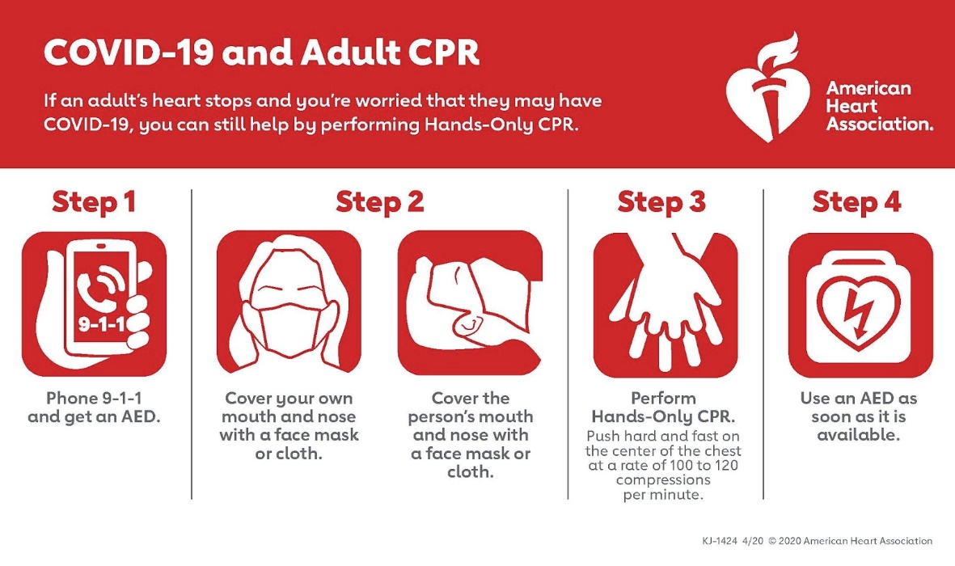
Figure 1: AHA Instructions for Adult CPR

Clean Site Checklist
The following checklist should be used for regular cleaning and disinfection of the sites:
Schedule regular twice daily cleaning and disinfection of bathrooms and portable toilets.
Recommended ratio for workers to portable toilets is one per 10 workers. Ensure portable toilets are space at least 6 feet (2 meters) apart.
Ensure eating areas if provided, are cleaned after each group.
Provide disinfecting wipes/sprays so tools and/or equipment that must be shared can be cleaned/disinfected between uses.
Sanitation/Disinfection wipes/sprays should be provided in each piece of shared equipment for workers to clean/sanitize before and after use. This includes but is not limited to controls, seats, seatbelts and other frequently touched surfaces associated with operation of the equipment.
Establish cleaning protocols and schedules in high-contact workspaces.
Provide additional tools, equipment, PPE, and signage to ensure potentially infected areas can be cleaned thoroughly and safely. This includes, but is not limited to:
- Barrier tape, stanchions, cones, or other temporary barricading methods.
- Disposable gloves.
- Respirator and/or face shield per products instructions.
- Protective clothing (i.e., disposal gown, Tyvek suit).
Consult OSHA guidelines for use of personal protective equipment.
Disinfect/sanitize all common or high-traffic areas including, but not limited to:
- Handrails.
- Tool box handles and locks.
- Storage room/container door handles and locks.
- Doorknobs.
- Lunch areas.
- Conference rooms.
- Other shared/common areas.
- Restrooms.
- Elevator buttons.
- Faucets.
- Toilet seats.
- Light switches.
- To the extent practicable, delivery personnel should remain in their vehicles.
- Use disposable nitrile/latex gloves when handling packages or wash your hands afterwards.
Where work trailers are used, only necessary employees should enter the trailers and all employees should maintain social distancing while inside the trailers. Site trailers in use should be disinfected at least once per day.
Trash must be removed frequently (minimum daily) by someone wearing nitrile, latex, or vinyl gloves.
When employees perform construction and maintenance activities within occupied homes, office buildings, and other establishments, these work locations present unique hazards with regards to COVID-19 exposures. All such workers should evaluate the specific hazards when determining best practices related to COVID-19.
During work, employees must disinfect the work areas upon arrival, throughout the workday, and immediately before departure.
Employees should remind other occupants to keep a personal distance of 6 feet (2 meters) at a minimum. Workers should wash or sanitize hands immediately before starting and after completing the work.

Disinfecting Instructions
Refer to the EPA List N: Disinfectants for Use against COVID-19
https://www.epa.gov/pesticide- registration/list-n-disinfectants-use-against-sars-cov-2
Management may approve the use of bleach solutions for disinfecting and assign a worker(s) to make the solution. To make a bleach solution, mix:
- 5 tablespoons (1/3 cup) bleach per gallon of water OR
- 4 teaspoons bleach per quart of water
Follow the manufacturer’s instructions for application and proper ventilation. Verify that the product is not past its expiration date. Never mix household bleach with ammonia or any other cleanser. Unexpired household bleach will be effective against coronaviruses when properly diluted.
Ensure alcohol solutions have at least 60% ethanol or 70% isopropyl alcohol.
Products with EPA-approved emerging viral pathogen claims are expected to be effective against COVID- 19 based on data for harder to kill viruses. Follow the manufacturer’s instructions for all cleaning and disinfection products (e.g., concentration, application method, and contact time, etc.).

Appendix A: Sample COVID-19 Site Access Questionnaire
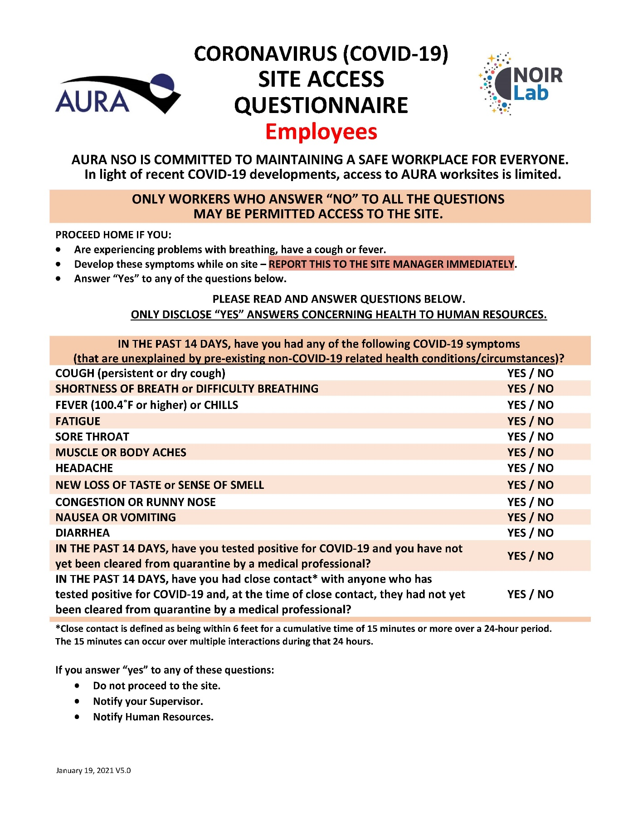
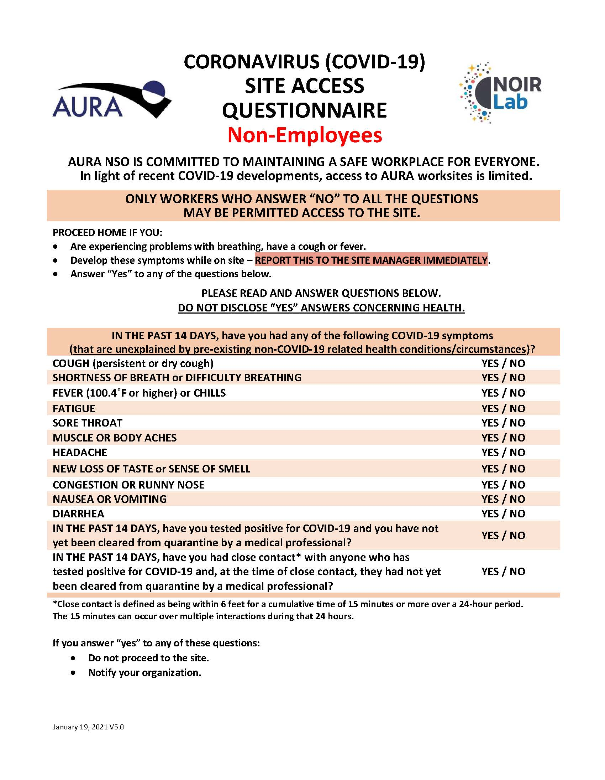

Appendix B: Sample Site Inspection Checklist
